To set up Kali Linux on a virtual machine, you will need to download and install two main things:

1. **The Kali Linux Installer Image (ISO file):** This is the operating system itself that you will install inside your virtual machine.
2. **Oracle VirtualBox (the hypervisor software) and its Extension Pack:** VirtualBox is the program that creates and runs virtual machines on your computer.

Here's how to download them:

**1. Download the Kali Linux Installer Image**

Based on the Kali Linux download page you provided:

* Go to the Kali Linux download page (if you're not already there).
* Scroll down to the section titled **"Installer Images."**
* Under **"Kali Linux 2025.2 Changelog,"** choose the architecture that matches your computer:
  + **x86_64**: For most standard desktop or laptop computers (Intel/AMD CPUs).
* 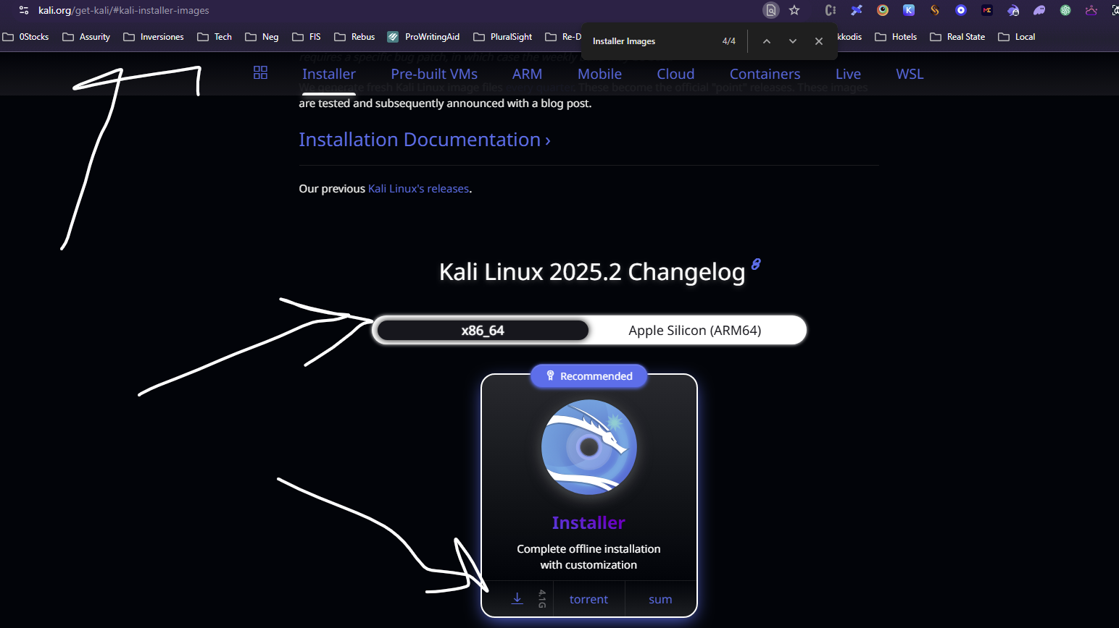
  + **Apple Silicon (ARM64)**: For newer Macs with M1/M2/M3 chips.
* Under your chosen architecture, find the row labeled **"Installer"** (which states "Complete offline installation with customization").
* Click on the **torrent** link next to it. This will download a small torrent file, which you'll then open with a torrent client (like qBittorrent or uTorrent) to download the large .iso installation file. If you prefer a direct download, sometimes there's a direct download link, but the torrent is usually recommended for large files.

**2. Download and Install Oracle VirtualBox and its Extension Pack**

As mentioned in the tutorial:

* **Download VirtualBox:**
  + Go to the official VirtualBox download page: https://www.virtualbox.org/wiki/Downloads
  + Under "VirtualBox [version number] platform packages," click the link corresponding to your computer's operating system (e.g., "Windows hosts," "macOS hosts," or "Linux distributions").
  + Run the downloaded installer file and follow the prompts to install VirtualBox.
* **Download VirtualBox Extension Pack:**
  + Go back to the same VirtualBox download page: https://www.virtualbox.org/wiki/Downloads
  + Scroll down to the **"Oracle VM VirtualBox Extension Pack"** section.
  + Click the **"All supported platforms"** link to download it.
  + Once downloaded, double-click the .vbox-extpack file and follow the prompts to install it.

Once you have both the Kali Linux ISO file and VirtualBox (with its Extension Pack) installed, you'll be ready to proceed with setting up your virtual machine as described in the tutorial.

is this what i need to install Installer

Complete offline installation with customization

Show thinking

Yes, that's correct!

When you're looking at the Kali Linux download page, the "Installer" option under "Installer Images" is exactly what you need to download for a complete offline installation that you'll use to set up your virtual machine. This is the .iso file that contains everything required to install Kali Linux.

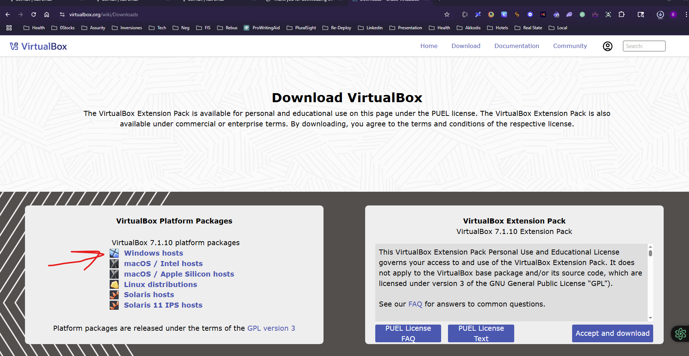

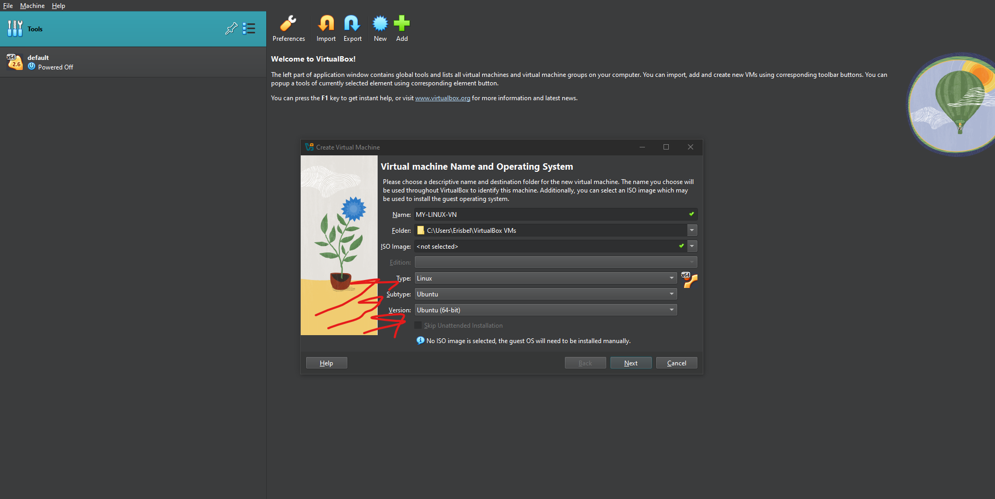

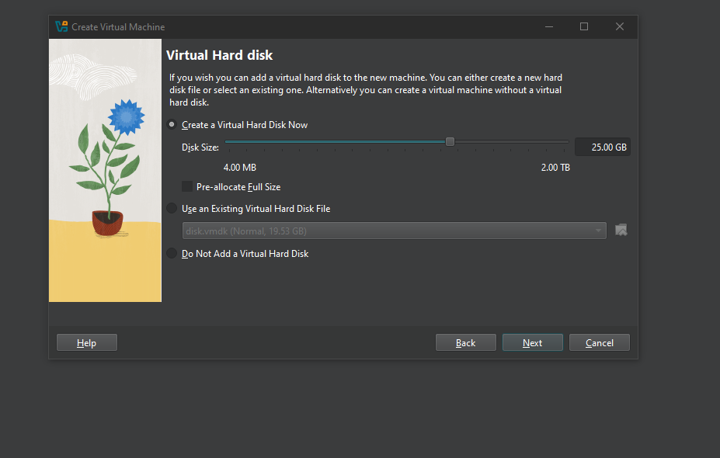

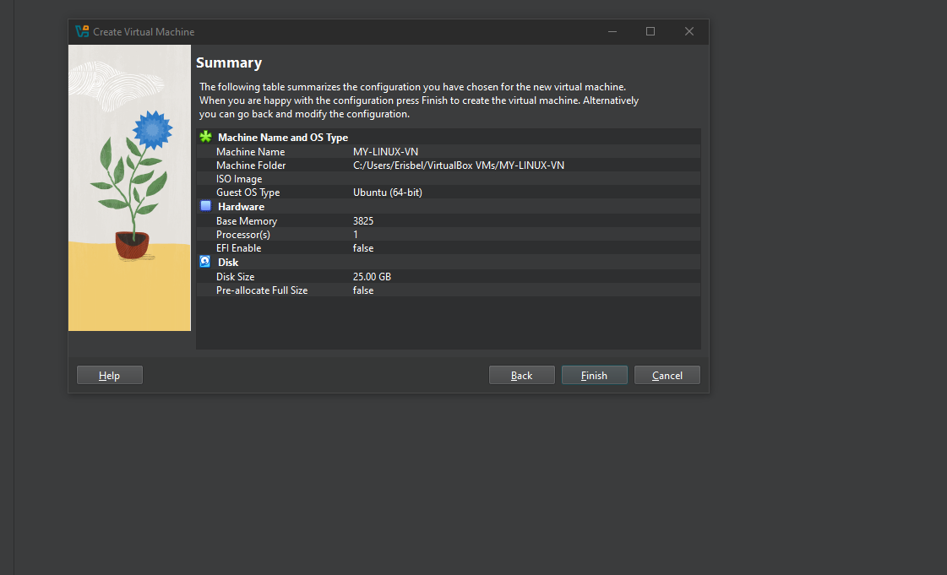

WHEN I RUN THE VM I SEE BELOW ERROR

NOW I NEED TO INSTALL THE OS

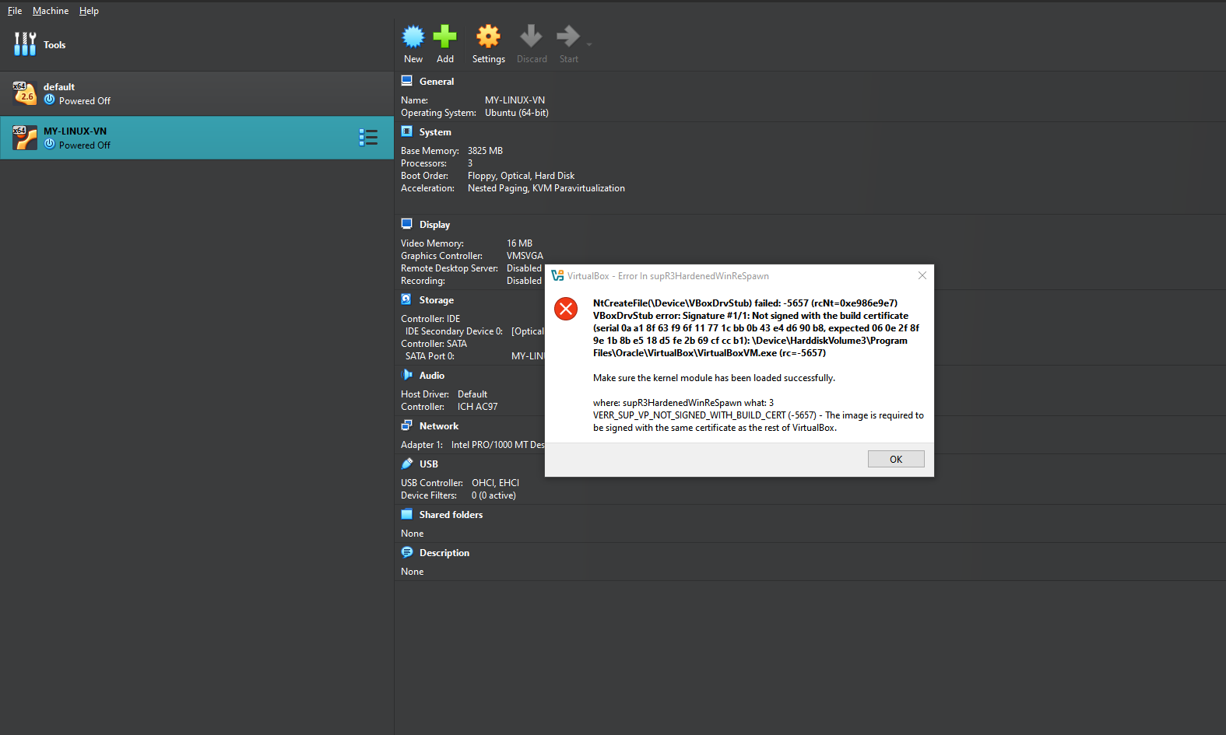

**VM Name:** MY-LINUX-VN

The virtual machine **'MY-LINUX-VN'** has terminated unexpectedly during startup with exit code -1073740791 (0xc0000409). More details may be available in **'C:\Users\Erisbel\VirtualBox VMs\MY-LINUX-VN\Logs\VBoxHardening.log'**.

|  |  |
| --- | --- |
| Result Code: | E_FAIL (0x80004005) |
| Component: | MachineWrap |
| Interface: | IMachine {e36a5081-a82a-40bd-9e4e-42a44d6ce50f} |
| 4634.1d80: ntdll.dll: timestamp 0x3af2a74f (rc=VINF_SUCCESS)  4634.1d80: New simple heap: #1 000002ccfc2f0000 LB 0x400000 (for 2064384 allocation)  3f4.47d0: supR3HardNtEnableThreadCreationEx:  4634.1d80: supR3HardenedWinInitAppBin(0x0): '\Device\HarddiskVolume3\Program Files\Oracle\VirtualBox'  4634.1d80: System32: \Device\HarddiskVolume3\Windows\System32  4634.1d80: WinSxS: \Device\HarddiskVolume3\Windows\WinSxS  4634.1d80: KnownDllPath: C:\Windows\System32  4634.1d80: supR3HardenedVmProcessInit: Opening vboxsup stub...  4634.1d80: supR3HardenedWinReadErrorInfoDevice: 'Signature #1/1: Not signed with the build certificate (serial 0a a1 8f 63 f9 6f 11 77 1c bb 0b 43 e4 d6 90 b8, expected 06 0e 2f 8f 9e 1b 8b e5 18 d5 fe 2b 69 cf cc b1): \Device\HarddiskVolume3\Program Files\Oracle\VirtualBox\VirtualBoxVM.exe'  4634.1d80: Error -5657 in supR3HardenedWinReSpawn! (enmWhat=3)  4634.1d80: NtCreateFile(\Device\VBoxDrvStub) failed: -5657 (rcNt=0xe986e9e7)  VBoxDrvStub error: Signature #1/1: Not signed with the build certificate (serial 0a a1 8f 63 f9 6f 11 77 1c bb 0b 43 e4 d6 90 b8, expected 06 0e 2f 8f 9e 1b 8b e5 18 d5 fe 2b 69 cf cc b1): \Device\HarddiskVolume3\Program Files\Oracle\VirtualBox\VirtualBoxVM.exe  3f4.47d0: supR3HardenedWinCheckChild: enmRequest=2 rc=-5657 enmWhat=3 supR3HardenedWinReSpawn: NtCreateFile(\Device\VBoxDrvStub) failed: -5657 (rcNt=0xe986e9e7)  VBoxDrvStub error: Signature #1/1: Not signed with the build certificate (serial 0a a1 8f 63 f9 6f 11 77 1c bb 0b 43 e4 d6 90 b8, expected 06 0e 2f 8f 9e 1b 8b e5 18 d5 fe 2b 69 cf cc b1): \Device\HarddiskVolume3\Program Files\Oracle\VirtualBox\VirtualBoxVM.exe  4634.1d80: KiUserExceptionDispatcher: 0xc0000005 (0000000000000001, 0000000000000024) @ 00007ffd4f2349e6 (flags=0x0)  rax=0000000000000000 rbx=00007ffd4f33c3c0 rcx=00007ffd4f33c3c0 rdx=00000000fffffffa  rsi=0000000000000000 rdi=00007ffd4f33c000 r8 =0000000000000000 r9 =00007ffd4f33c300  r10=0000000000000000 r11=000000fed88fa710 r12=0000000000000000 r13=000000fed864f000  r14=0000000000000001 r15=0000000000000000 P1=000000fed88fa850 P2=00007ff67138226b  rip=00007ffd4f2349e6 rsp=000000fed88fa570 rbp=00000000ffffe900 ctxflags=0010005f  cs=0033 ss=002b ds=002b es=002b fs=0053 gs=002b eflags=00010213 mxcrx=00001f80  P3=000000fed88f9f50 P4=00007ff60000000a P5=0000006200000000 P6=00007ff67138203e  dr0=0000000000000000 dr1=0000000000000000 dr2=0000000000000000 dr3=0000000000000000  dr6=0000000000000000 dr7=0000000000000000 vcr=0000000000000000 dcr=0000000000000000  lbt=0000000000000000 lbf=0000000000000000 lxt=0000000000000000 lxf=0000000000000000  3f4.47d0: Error -5657 in supR3HardenedWinReSpawn! (enmWhat=3)  3f4.47d0: NtCreateFile(\Device\VBoxDrvStub) failed: -5657 (rcNt=0xe986e9e7)  VBoxDrvStub error: Signature #1/1: Not signed with the build certificate (serial 0a a1 8f 63 f9 6f 11 77 1c bb 0b 43 e4 d6 90 b8, expected 06 0e 2f 8f 9e 1b 8b e5 18 d5 fe 2b 69 cf cc b1): \Device\HarddiskVolume3\Program Files\Oracle\VirtualBox\VirtualBoxVM.exe |  |

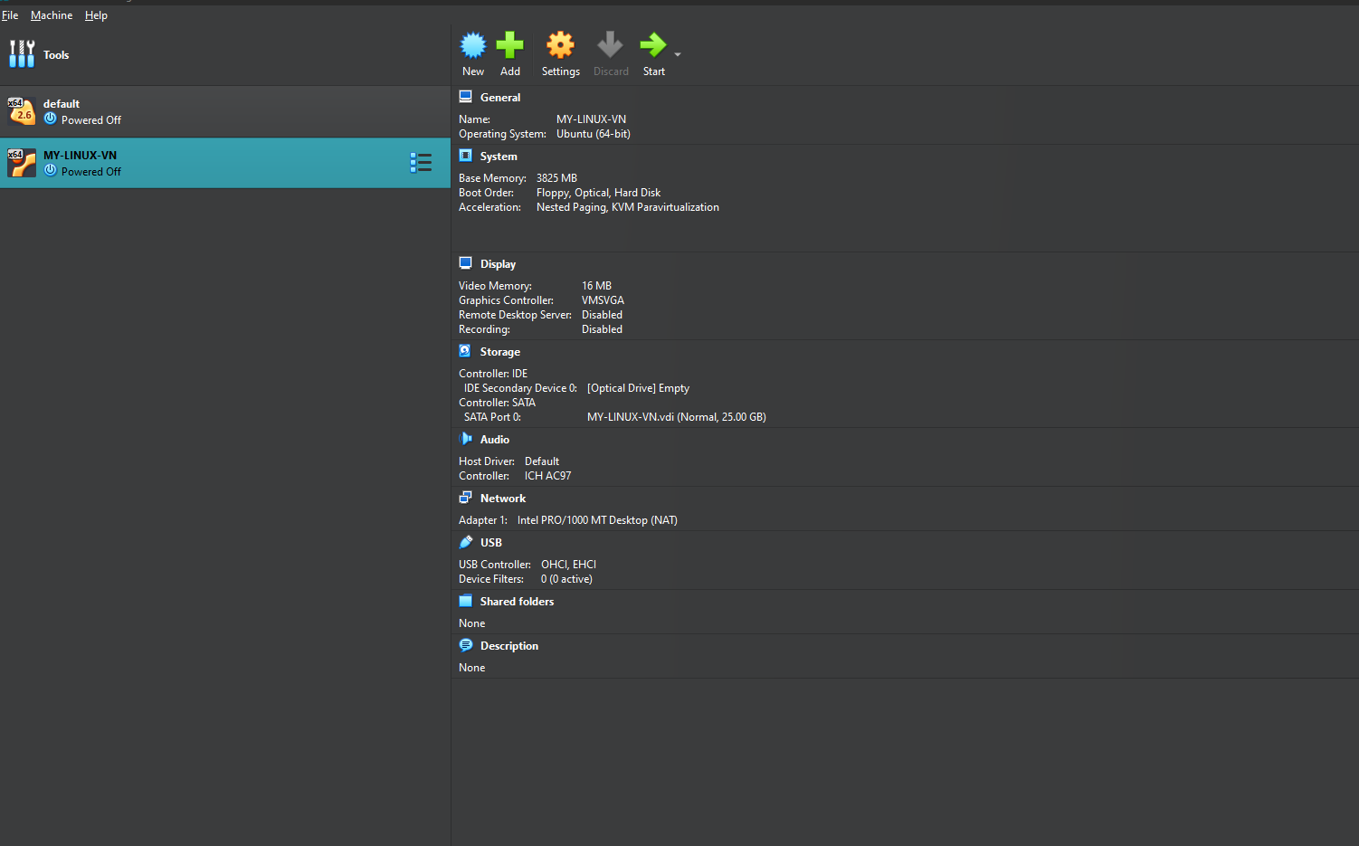

Fater rebutting , the error

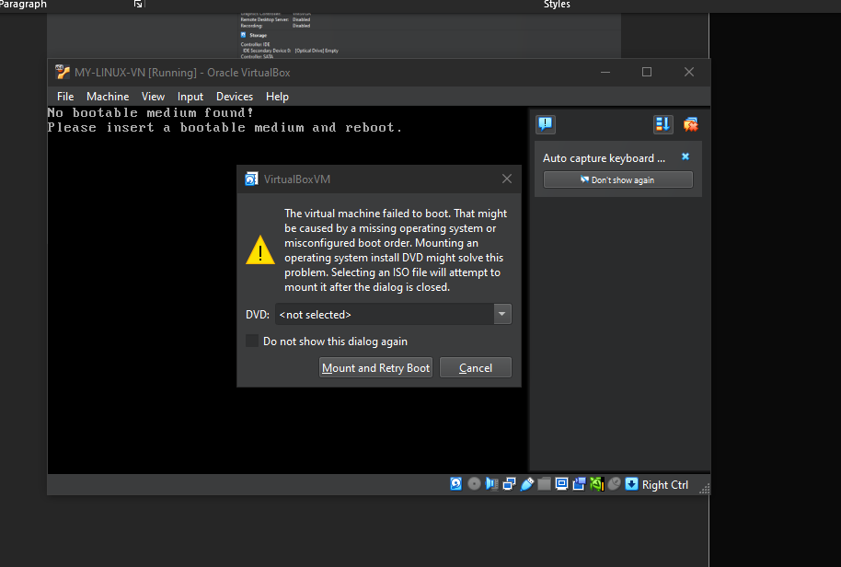

Borwose and install .iso for kali and ubuntu

C:\Dowloads-Installs

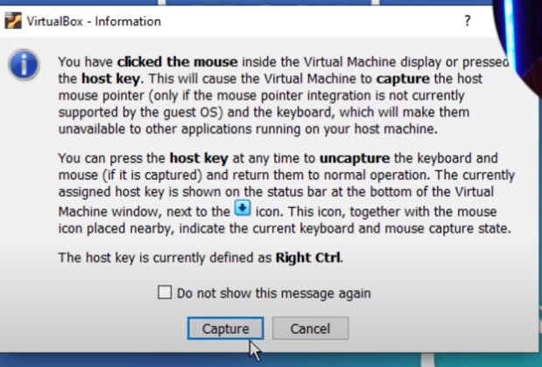

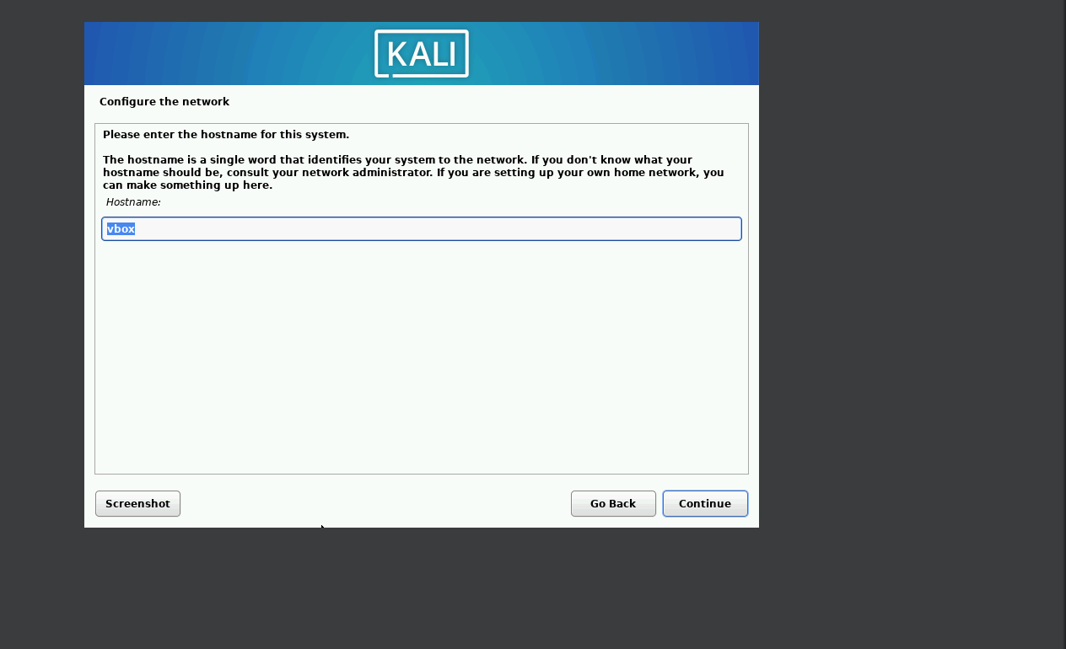

User name : ericuser  
Pw: Kali14001@!  
network:attlocal.net  
host name : vbox

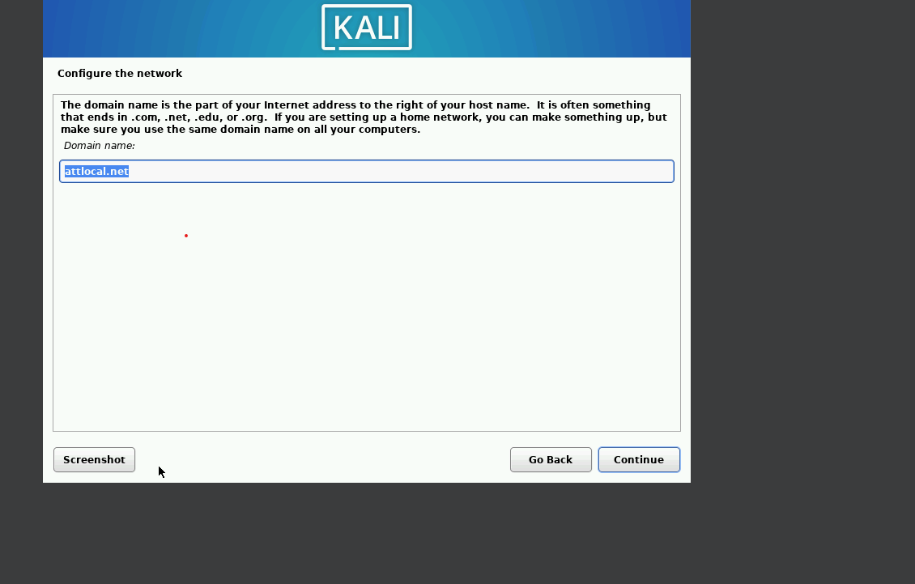

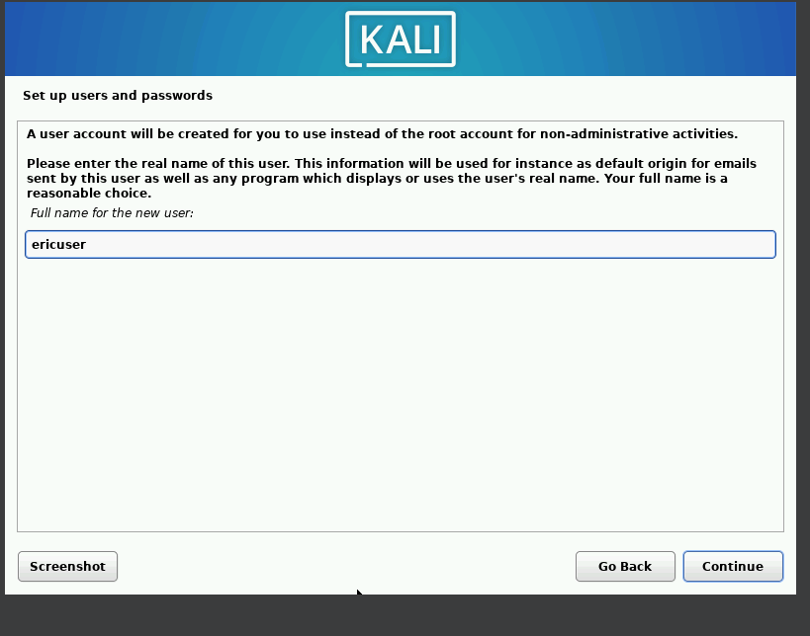

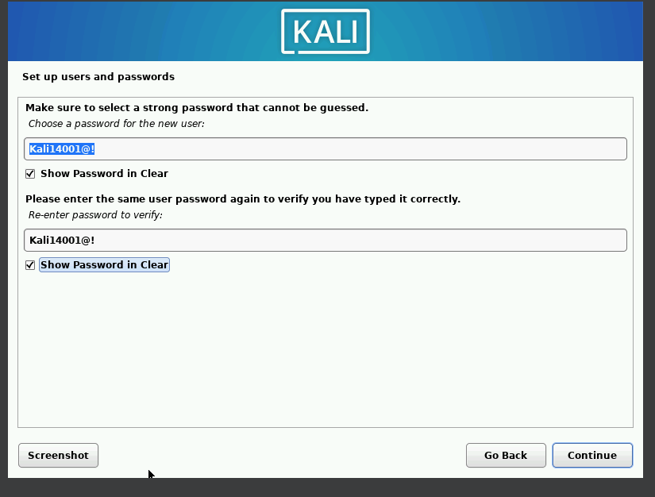

Format the entire disk it has access too .

